**BUS 322 F23 AACSB**

**ASSESSMENT**

1. Compute the relative frequencies for the data given in the table below:

|  |  |
| --- | --- |
| **Grades** | **Number of students** |
| A | 16 |
| B | 28 |
| C | 33 |
| D | 13 |
| Total | 90 |

1. 0.31, 0.14, 0.37, 0.18
2. 0.37, 0.14, 0.31, 0.18
3. 0.14, 0.31, 0.37, 0.18
4. 0.18, 0.31, 0.37, 0.14
5. A marketing research consultant hired by Coca-Cola is interested in determining if the proportion of customers who prefer Coke to other brands is over 50%. A random sample of 200 consumers was selected from the market under investigation, 55% favored Coca-Cola over other brands. Additional information is presented below.

|  |  |
| --- | --- |
| Sample proportion | 0.55 |
| Test Value | 0.03518 |
| Z test statistic | 1.4213 |
| p-value | 0.07761 |
|  |  |

A consultant has decided on One-tailed test in order to find whether the proportion is actually greater than 50%. Using a 5% significance level, can the marketing consultant conclude that the proportion of customers who prefer Coca-Cola exceeds 50%?

1. Yes
2. No
3. Not enough information is provided to make a correct decision
4. The test should be two-sided test and therefore there is no right answer
5. Robin Inc. feared that the average company loss is running beyond $34,000. It initially conducted a hypothesis test on a sample extracted from its database. The hypothesis was formulated as *H*0: average company loss $34,000 vs. *H*1: average company loss > $34,000. The test resulted in favor of Robin Inc.'s loss not exceeding $34,000. Detailed study of company accounts later revealed that the average company loss had run up to $37,896. Which of the following errors were made during the hypothesis test?
6. Type III error
7. Type II error
8. Type I error
9. Type IV error
10. The scatter chart below displays the residuals verses the independent variable, x. Which of the following conclusions can be drawn from the scatter chart given below?

1. The residuals have an increasing variance as the independent variable increases.
2. The model captures the relationship between the variables accurately.
3. The regression model follows the standard normal probability distribution.
4. The residual distribution is consistently scattered about zero.
5. The CEO of a company wants to estimate the percent of employees that use company computers to go on Facebook during work hours with 95% confidence. He selects a random sample of 150 of the employees and finds that 53 of them logged onto Facebook that day. What is the point estimate of the proportion of the population that logged onto Facebook that day?
   1. 0.53
   2. 0.35
   3. 0.25
   4. 0.65
6. A survey was conducted by a research team to investigate how the education level and years of experience are related to the annual income. Based on the survey’s definition, education level is a categorical variable with five possible levels of “high school”, “college”, “some college”, “university”, and “graduate”. How many dummy variables the analyst should add to the regression model in order to capture “education level” as an independent variable?
7. 5
8. 4
9. 3
10. 2

1. Listed below is a company's sales in the period 2000 to 2011 along with the national income of the country, where the business is set up.

|  |  |  |
| --- | --- | --- |
| Year | National Income  (in millions of $) | Company's sales  (in thousands of $) |
| 2000 | 305 | 470 |
| 2001 | 316 | 485 |
| 2002 | 358 | 499 |
| 2003 | 350 | 515 |
| 2004 | 375 | 532 |
| 2005 | 392 | 532 |
| 2006 | 400 | 556 |
| 2007 | 398 | 576 |
| 2008 | 430 | 583 |
| 2009 | 456 | 587 |
| 2010 | 578 | 601 |
| 2011 | 498 | 605 |

Consider the following as the estimated regression analysis using excel that could be used to estimate the company's yearly sale, given the yearly national income.

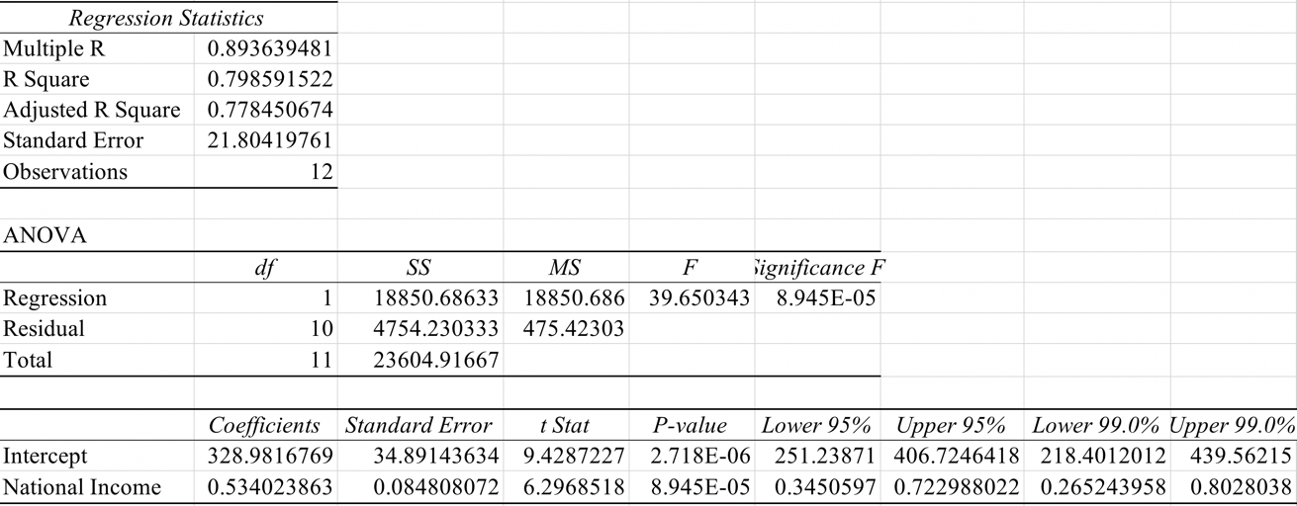

What is the estimated regression equation that can be used to predict the company's sale using the national income?

1. Consider the estimated regression problem in Questions 8. What is the conclusion of the test that determines the regression parameters is equal to zero at a 0.01 level of significance? (Assume that the conditions necessary for proper inference are satisfied)

a. National income is a significant indicator of the company sale.

b. National income is not a significant indicator of the company sale.

c. Intercept is a significant indicator of the company sale.

d. Intercept is not a significant indicator of the company sale.

1. Which of the following data patterns best describes the scenario shown in the below plot?

1. Time series with a linear trend pattern
2. Time series with a nonlinear trend pattern
3. Time series with no pattern
4. Time series with a horizontal pattern
5. Consider the following sales time series data:

|  |  |  |  |  |  |  |  |  |  |  |
| --- | --- | --- | --- | --- | --- | --- | --- | --- | --- | --- |
| Year | 1 | 2 | 3 | 4 | 5 | 6 | 7 | 8 | 9 | 10 |
| Value | 234 | 287 | 255 | 310 | 298 | 250 | 456 | 412 | 525 | 436 |

Using the moving average with what is the estimate sales forecast for year 11?

1. 436
2. 412
3. 458
4. 525

1. _________ are a tool in Excel that summarize the data of a more extensive table and allow for calculation and analysis of data in tabular format.

a. PivotTables

b. Scatter Charts

c. Relational Tables

d. Heat Maps

e. Scatter Chart Matrices

1. _______ is best defined as detailed facts collected from members of a population.

a. information

b. insight

c. science

d. data