**National University**

**DEN 432**

**Concurrent Design Engineering**

**Project Description**

**as of 1/9/24**

A stapler is a common office tool designed for fastening sheets of paper together by driving a metal staple through them. Here is a picture of a very popular office stapler:

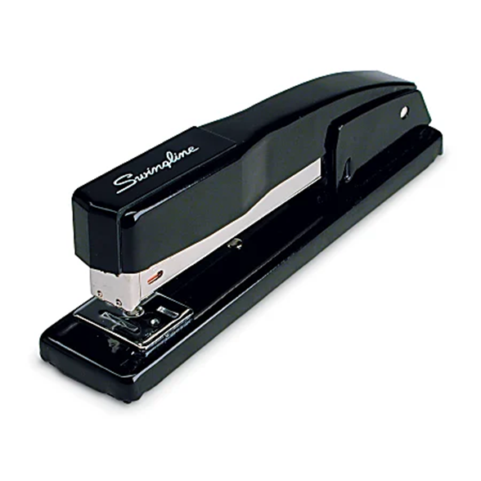

The model can staple up to 20 sheets of paper. The tray can hold 210 standard staples.

The objective of your assignment is redesign this stapler to lower the number of parts and maintaining the same functionality.

Please use the best practices of the reversed engineeing and concurrent design engineering, processes.

Please document your work in the final engineering report.