**Morphology Charts**

In design, a morphology chart is a visual tool used to explore and organize different design concepts or solutions. It is particularly common in the field of product design and engineering. The chart typically consists of a grid with rows and columns, where each row represents a specific attribute or component of a design, and each column represents a variation or option for that attribute.

The purpose of a morphology chart is to systematically generate and explore potential design alternatives by combining various options for each attribute. This method allows designers to break down a complex design problem into smaller, more manageable parts, facilitating a structured and comprehensive exploration of possible solutions.

Key aspects of the morphology chart include:

**1. Attributes:** These are the characteristics or components of the design that can be varied. For example, in product design, attributes could include material, color, shape, size, etc.

**2. Options:** Each attribute has multiple options or variations that can be considered. For instance, if the attribute is color, the options could be red, blue, green, etc.

**3. Combinations:** By systematically combining different options for each attribute, designers can generate a wide range of design concepts. This helps in considering various possibilities and finding innovative solutions.

The importance of a morphology chart in design lies in its ability to:

**• Systematize Exploration**: It provides a structured framework for exploring a variety of design possibilities, ensuring that designers consider a broad range of options.

**• Facilitate Communication:** It serves as a communication tool among team members, stakeholders, and clients. It helps in conveying design ideas and variations in a clear and organized manner.

**• Enhance Creativity:** By encouraging the exploration of diverse combinations, the chart stimulates creative thinking and can lead to novel and innovative design solutions.

**• Efficient Decision-Making:** Designers can use the chart to evaluate and compare different design alternatives, making the decision-making process more efficient and informed.

By systematically combining options, designers can generate a variety of chair design concepts. This process allows for exploration and consideration of different possibilities, helping in the development of innovative and diverse design solutions.

To illustrate how a morphology chart can be used to show that a particular function can be fulfilled by either an assembly, module, or a set of parts, let's consider a hypothetical example related to designing a camera system. We'll focus on the function of capturing and processing images, and how this function can be realized through different design configurations.



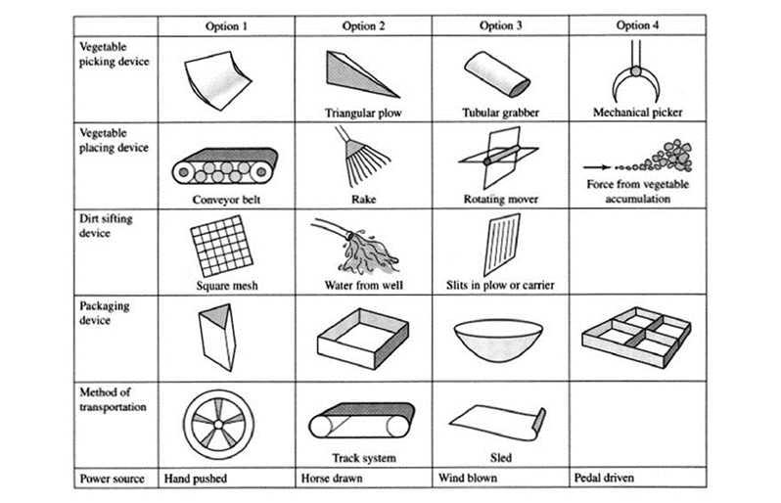

By using the morphology chart in this way, designers can clearly communicate and explore different configurations for fulfilling a specific function. It allows for the consideration of various combinations of assembly, module, or set of parts to achieve the desired functionality within the overall design. This systematic approach helps in making informed decisions about the design architecture and configuration.