Evaluating the Effectiveness of ICE-Drones for Enhanced Search & Rescue

with the United States Coast Guard

Team Name: Fantastic Five

Submitted to

The Department of Engineering and Computing

National University

In Partial Fulfillment of the Requirements

for the Degree of Master of Science in Engineering Management

By:

Javier Delgado-Garcia, Rocio Rivera, Joanne Ro, Gloria Rorie, Koffi Yegbe

October 2023

**MASTER’S CAPSTONE PROJECT APPROVAL FORM**

This capstone project paper has been submitted to the Department of Engineering and Computing, National University, in partial fulfillment of the requirements for the Master of Science in Engineering Management by:

_________________________

Javier Delgado-Garcia

_________________________

Rocio Rivera

_________________________

Joanne Ro

_________________________

Gloria Rorie

_________________________

Koffi Yegbe

This report is hereby approved by:

________________________________ _____________________

Ben D Radhakrishnan, M.Tech., M.S., M.B.A. Date

Academic Program Director – MS Engineering Management

Sustainable Business Practices Certification

Dept of Engineering and Computing

National University

________________________________ _____________________

Derek Podobas, MS Date

Department of Engineering and Computing

National University

Copyright © 2023 by Team Fantastic Five and National University

All Rights Reserved

**Abstract**

This study presents a systems approach analysis into the potential integration of a gasoline-powered long-range drone, specifically the Armada Drone, within the United States Coast Guard (USCG) to enhance Search and Rescue (SAR) missions. The study systematically defines the problem, establishes key objectives, and develops an analytical simulation model to assess the impact of implementing this technology on search effectiveness. The project's primary sponsor, Armada Research and Development, seeks to explore the feasibility of expanding its drone service to SAR ventures in the United States. The study evaluates the specified independent variables of endurance, swath width, speed, and readiness time, utilizing mathematical and simulation models to quantify the potential enhancement in search efficiency. Through three distinct scenarios, the study demonstrates significant improvements in search efficiency and effectiveness, providing insights crucial for decision-making in incorporating drones for search and rescue operations with the USCG. The findings reveal a notable increase in search efficiency and suggest that integrating the Armada Drone could lead to a substantial enhancement in SAR mission outcomes, demonstrating its potential to save lives and optimize search operations.

**Team Biographies**

**Javier Delgado-Garcia** has a B.S. degree in Mechanical Engineering from Instituto Tecnologico Nacional de Mexico. He is currently employed by Pfizer in San Diego as the Lead of the Energy and Sustainability team for Region 3 in North America as well as the SME on HVAC systems.

**Rocio Rivera** has a B.S. degree in Business Management with a focus in Human Resources from Regent University in Virginia Beach, VA. She is currently an Integration and Test IPT Project Manager at Northrop Grumman. She lives in Temecula, California.

**Joanne Ro** has a B.S. degree in International Business from California State University, Long Beach. She is currently employed as a Configuration Analyst at Northrop Grumman. She lives in Long Beach, California.

**Gloria Rorie** has a B.S. degree in Electrical and Computer Engineering. She is currently employed as a System Architect at NAVWAR San Diego. She lives in San Diego, California.

**Koffi Yegbe** has a B.S. degree in Construction Engineering Technology from National University. He is currently a U.S. Navy Sailor. He lives in Chesapeake, VA.

Table of Contents

CHAPTER 1: Introduction and Project Overview 9

Project and Sponsor Background 9

Problem Statement 9

Key Objective 11

The Scope of the Project 12

Limitations of the Study 12

Chapter Summary 13

CHAPTER 2: Methodology and Data Collection 13

Project Decomposition & Morphology 13

A Quick Intro to Search Operations 15

Armada Drone Technical Specifications 16

Definition of Variables 18

Mathematical Model 18

Simulation Model 23

CHAPTER 3: Interpretation of Results 26

Constraints & Variables 26

Defined Variables for Scenario #1 & #2 27

Scenario #1 27

Scenario #2 28

Scenario #3 29

CHAPTER 4: Risk Management 31

Capstone Project Risks 31

Armada Drone Implementation Risks 32

CHAPTER 5: Conclusions and Recommendations 34

Lessons Learned 35

Recommendations 35

Appendices 37

Appendix A: Capstone Milestone & PERT Tables 37

Appendix B: Letter of Engagement 40

Appendix C: Project Decomposition and Morphology Chart 50

References 51

List of Tables

Table 1 U.S. Coast Guard Mission Programs 10

Table 2 Swath width for different flying altitudes and visibility conditions 22

Table 3 Search aircraft speed correction 22

Table 4 Recommended search altitudes 22

Table 5A Project Milestones 37

Table 6A PERT estimated time of completion 38

Table 7A Critical path & standard deviation 38

Table 8A PERT probability of project completion 39

List of Figures

Figure 1 Swath width 23

Figure 2 SAROPS probability grid 23

Figure 3 Vensim simulation model 24

Figure 4 Effective time of search with drone implementation function 25

Figure 5 Search efficiency with drone implementation function 25

Figure 6 Sample Scenario A 26

Figure 7 Scenario #1 28

Figure 8 Scenario #2 29

Figure 9 Scenario #3 30

Figure 10 Simulation model results 31

Figure 11A PERT diagram 38

Figure 12C Fishbone diagram 50

Figure 13C Flow diagram 50

**Definition of Terms**

**ICE** Internal Combustion Engine

**UAS** Unmanned Aircraft System

**USCG** United States Coast Guard

**RF** Radio Frequency

**SAR** Search and Rescue

**SAROPS** Search and Rescue Optimal Planning System

**DHS** Department of Homeland Security

**Vensim** A simulation model software for the analysis of dynamic systems

# CHAPTER 1: Introduction and Project Overview

## Project and Sponsor Background

The purpose of this study is to fulfill the requirements for the Master of Science in Engineering Management at National University. The primary objective of this research is to assess the efficacy of implementing a gasoline-powered long-range drone within the United States Coast Guard (USCG) for the purpose of enhancing Search and Rescue (SAR) missions. The study follows a systematic step-by-step approach encompassing problem definition, determination of the key objective (dependent variable), followed by project decomposition and morphology, and the development of an analytical simulation model. The conclusions drawn in this study are substantiated by comprehensive data collection, analysis, and the results obtained from simulated models.

The sponsor of this study is Armada Research and Development, a subsidiary of a Canadian pharmaceutical company, currently operating in Canada, the Middle East, and the United States. The main objective of the company is to assess the feasibility of introducing its gasoline-powered long-range drone in new ventures. Presently, Armada utilizes its drone for delivery services to remote communities in Canada and is interested in expanding to search and rescue ventures within the United States. The insights derived from this study will form the basis for fundraising initiatives for capital raise in this venture.

## Problem Statement

The USCG operates under the Department of Homeland Security (DHS) and encompasses 11 distinct mission programs. Among these, the SAR mission is integrated into the USCG’s Maritime Response program.

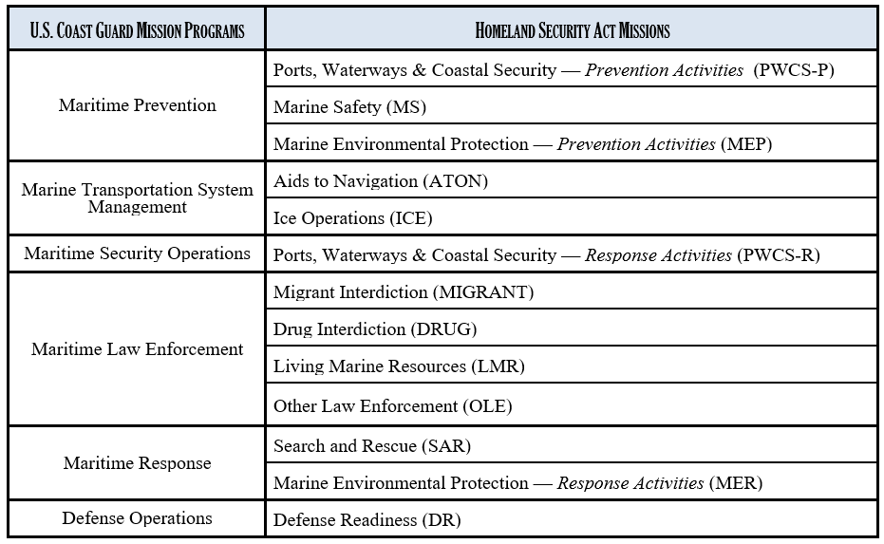

Table U.S. Coast Guard Mission Programs

As one of the earliest and fundamental missions of the USCG, the main purpose of SAR is to minimize the loss of life and property by searching for and providing aid to persons in distress within the maritime domain. In recent years and to stay current with emerging technology, the USCG has increasingly adopted drones, called unmanned aircraft systems (UAS), to augment several missions, particularly in the search phase of SAR operations. The integration of drones offers significant operational benefits, including lower operational costs, improved safety for operators, and optimized search methodologies (Murray, 2021). It's important to note that while drones cannot replace traditional SAR vessels like aircraft, cutters, and boats essential for actual rescue operations, they considerably enhance the efficiency and safety of the search phase for the manned crews involved.

Armada's long-range gas-powered drone is equipped with a fuel-efficient engine, ensuring increased endurance and optimal fuel consumption. This study aims to investigate the potential enhancement of search effectiveness in SAR missions by 10% through the integration of Armada's drone. The effectiveness of SAR missions is influenced by various factors such as location, weather conditions, equipment, training, and mission specifics. In this study, we will focus on analyzing specific variables related to performance, including endurance, swath width, speed, and system deployment readiness following a distress call. The baseline search effectiveness, representing the current state without drone implementation, has been established at 100%. We will measure the search effectiveness post-drone implementation (the proposed state) against this baseline to determine the extent of improvement, if any.

## Key Objective

This study endeavors to ascertain whether the integration of the proposed drone in SAR operations can result in a 10% enhancement of search efficacy. Assuming a current benchmark of 100% in search effectiveness in the US Coast Guard, incorporating Armada's long-range gas-powered drone into the search phase of SAR missions is expected to yield a 10% increase in search effectiveness This objective aligns with the requirements of the SMART+ objectives.

* *Specific*: The specific goal is to enhance the efficiency of search operations in the US Coast Guard SAR mission.
* *Measurable*: Measuring success involves reducing the average time required to locate and initiate rescue for distressed individuals.
* *Achievable*: Attaining this goal is feasible through the effective implementation of Armada drones.
* *Realistic*: Improving search operation efficiency is realistic and aligns with the US Coast Guard's vital mission of saving lives.
* *Time-bound*: The objective is set to be achieved within the next 2 years post-implementation.
* *Ethical*: A theoretical increase in search effectiveness is ethically sound, potentially leading to more lives saved in SAR missions.

We have carefully evaluated our project objectives through an ethical lens and are confident that this project meets all ethical criteria, warranting pursuit.

## The Scope of the Project

The scope of this project will be limited to the following:

* Analysis of the defined independent variables
  + Endurance
  + Swath Width
  + Speed
  + Readiness Time
* Simulation model showing search effectiveness of current state & implementing drones in the search portion of SAR missions.
* Our evaluation of the improvement of efficacy due to implementation of the drones in SAR missions

The final deliverables are the final written report and the PowerPoint presentation.

## Limitations of the Study

The following topics and any deliverables not listed in this document are considered outside of the scope of this project.

* Financial Analysis
* Design of the drone
* Environmental Impacts
* Resource Allocation
* Maintainability and Reliability
* Legal and Regulatory Considerations
* Public Relations and Perceptions
* Search and Rescue Expertise

## Chapter Summary

In conclusion, this chapter provides a comprehensive view of the project's purpose and context, detailing the objective of evaluating the effectiveness of incorporating a gasoline-powered long-range drone within the USCG to enhance SAR missions. The problem statement underscores the importance of SAR missions, presenting the potential benefits and limitations associated with integrating UAS. The study's central objective is to determine a 10% improvement in search efficacy through the implementation of the proposed drone. This hypothesis aligns with the SMART+ objective requirements. The project's scope has been clearly defined, focusing on specific variables and simulation models to assess search effectiveness. Additionally, it delineates the study's limitations and areas outside its purview, offering a comprehensive summary of the study's key areas and boundaries.

# CHAPTER 2: Methodology and Data Collection

## Project Decomposition & Morphology

Presenting a simulation on implementing drones in search and rescue involved several steps to effectively communicate findings and recommendations to stakeholders. This process is initiated by clearly defining the goals and objectives of the simulated presentation. In the case of our model, the initial objective was to increase the likelihood of saving lives during SAR missions by a minimum of 10%. From this process, our Fishbone Diagram referenced in Figure 12C was developed by breaking down the stated independent variables (endurance, swath width, speed, readiness time) with other factors that impact these variables (cause and effect).

Using the data gathered, a methodology was developed to determine the statement of work and to specify the dependent and independent variables. The methodology was then used to develop and run various scenarios that would test our ability to meet the desired objective in combination with the performance specification shown in our methodology as shown in Figure 13C.

From the statement of work in the fishbone diagram and the methodology, our team separated the dependent and independent variables and defined the known current state of system operations during a SAR mission to determine the independent variables that will need to be manipulated to solve for time increase over time which defines efficiency and effectiveness. This process of separation allowed us to build our model which led to a change of objective that focuses on “Search Effectiveness,” as an end state versus lives saved, considering lives saved is a broader objective that did not have enough data to develop upon. Finally determining the flow of data would be supported by a stock and flow diagram that took into account the technical capabilities and increasing or upgrading attributes of individual devices to support mission effectiveness.

## A Quick Intro to Search Operations

Search planning is based on myriad variables including environmental factors, the nature, time, and location of the distress incident, the type(s) of search object(s) resulting from the distress, and the available search platforms and their capabilities, including the time at which they can be on the scene.

Search and rescue operations at sea are carried out to save sailors and passengers in distress, or the survivors of downed aircraft. The type of agency that carries out maritime search and rescue varies by country; in the U.S. it could be the Coast Guard, Navy, or voluntary organizations.

The search operation at sea is a complex process that involves several steps. The following is a brief overview of the steps involved in a typical search operation:

1. Assessment of the situation: The first step in any search operation is to assess the situation. This involves gathering information about the missing vessel or aircraft, such as its last known position, speed, and direction of travel.
2. Planning: Once the situation has been assessed, a search plan is developed. The plan takes into account factors such as weather conditions, visibility, and the quality of equipment available.
3. Deployment: The next step is to deploy the search vessels and aircraft. The vessels are equipped with sensors that can detect objects on or under the water surface, while aircraft are used to search for objects from above.
4. Search: The search vessels and aircraft then conduct a systematic search of the area where the missing vessel or aircraft is believed to be located. The area to be searched is determined by factors such as the last known position of the vessel or aircraft, currents, and wind direction.
5. Detection: If an object is detected during the search, it is identified, and its location is recorded. This information is then used to refine the search area.
6. Recovery: Once the missing vessel or aircraft has been located, recovery operations begin. This involves retrieving any survivors and any debris from the water.

The effectiveness of a search mission depends on several factors such as weather conditions, visibility, and the quality of equipment used. The duration of a search mission is determined by the urgency of the situation and the resources available.

## Armada Drone Technical Specifications

Drones can be powered by either internal combustion engines or batteries. Here are some advantages of using drones with internal combustion engines over battery-powered drones:

* Longer flight times: Drones with internal combustion engines can fly for longer periods than battery-powered drones. This is because they can carry more fuel than batteries can store energy.
* Higher power output: Internal combustion engines produce more power than batteries, which allows drones to fly faster and carry heavier payloads.
* Easier maintenance: Internal combustion engines are typically easier to repair and maintain long-term than batteries, which require replacement after a certain number of charge cycles.
* Refuel on demand: Drones with internal combustion engines can be refueled on demand, allowing them to return to flight without waiting for a battery charge.
* A wider range of applications: Drones with internal combustion engines are better suited for applications that require longer flight times and higher power output, such as aerial photography, surveying, and search and rescue operations.

However, there are also some disadvantages to using drones with internal combustion engines. They tend to be noisier and produce more emissions than battery-powered drones, which can be a concern in certain environments. Additionally, they require a fuel source, which can be more expensive than batteries in the long run.

The Armada ICE-powered drone has the following characteristics:

* Payload: 8 kg
* Engine: 85cc two-stroke, single-cylinder, 18.6kW
* Endurance: 11 hours
* Fuel usage: 0.56 liters per hour at full load
* Fuel type: Unleaded. Min 94 octanes
* Maximum wind speed: 60 km/h
* Maintainability: Fully modular, no specialties tools required.
* Maximum velocity: 110 km/h
* Maximum altitude: 400 ft limited only by aircraft regulations.

## Definition of Variables

* Endurance: The amount of time a search vessel or aircraft can remain at sea without refueling.
* Swath Width: The width of the area covered by a search vessel’s sensors in a single pass.
* Velocity at searching mode: The speed at which a search vessel moves while conducting a search.
* Time for readiness and refueling: The time required to prepare a search vessel for deployment and to refuel it upon return.
* Area to be searched: The geographical area that needs to be searched for the target.
* Time scheduled for the search mission: The duration of the search mission, which is determined by the urgency of the situation and the resources available.
* Effectiveness of the search mission: The degree to which the search mission achieves its objectives, which is influenced by factors such as weather conditions, visibility, and the quality of equipment used.

## Mathematical Model

The proposed mathematical model includes the variables that affect the effectiveness of a search using rotary-wing aircraft. For the purpose of this study, we will be limiting the evaluation of the current state of the USCG to the helicopter MH-65 "Dolphin" in comparison with the Armada drone to increase the effectiveness of the search portion of SAR missions.

The amount of search time available is of paramount relevance. It is clear that in most scenarios, survival rates decrease with time, therefore, the effectiveness of a search operation is a direct function of the time of the search.

When drones come to complement a search mission, the rate of area covered on time T is increased and therefore, the time for covering the assigned area decreases. The following equations describe the relationships between the above-mentioned variables.

**(Equation 1) Area covered in the assigned time** = (Endurance-Time to setup the aircraft)*(Velocity at searching mode)*(Swath width covered by sensors on board or human sight)*(number of units on the mission)*(time of search)/(Endurance*1000)

**(Equation 2) Effective time of search** = (Area to be covered*Assigned time of search)/(area covered in the assigned time + area covered by drones)

**(Equation 3) Effectiveness of the search mission** = Assigned time of search - Effective time of search)/Assigned time of search

There are several scenarios that can trigger a search mission at sea. Here are some examples:

* Distress signal: A distress signal from a vessel or aircraft indicates that they are in trouble and require assistance. This can be triggered by a variety of factors such as engine failure, fire, or collision.
* Missing vessel or aircraft: If a vessel or aircraft fails to arrive at its destination or loses contact with its base, it may trigger a search mission.
* Man overboard: If someone falls overboard from a vessel, it can trigger a search mission to locate and rescue them.
* Natural disasters: Natural disasters such as hurricanes, typhoons, and tsunamis can cause vessels to capsize or become stranded, which can trigger a search mission.
* Illegal activity: Illegal activities such as piracy, smuggling, and human trafficking can trigger a search mission by law enforcement agencies.
* Environmental pollution: Oil spills and other environmental disasters can trigger a search mission to contain the damage and rescue any affected wildlife.

These are just some examples of scenarios that can trigger a search mission at sea. The specific circumstances of each situation will determine the type of search operation required and the resources needed to carry it out.

The scenarios used to run the mathematical model require the following assumptions.

1. Endurance time flying before refueling is 11 hours for the Armada Drone and 3 hours for the MH-65.
2. Swath width is the same for both aircraft assuming they will fly at the same altitude with the same visibility conditions referenced in Table 2. The selected scenario is the search for a small raft with one person at 300 ft of altitude and visibility conditions at 10 NM, see Table 4. This value is 1.5 NM or 2.78 km. Searching a person in water would reduce the swath width to 0.1 NM or 0.185 km. No correction factors have been applied to these values. Several factors like weather, aircraft speed, fatigue, daylight, etc. can increase or decrease this uncorrected value. See Figure 1.
3. Speed at searching mode. According to Table 3, the velocity for a rotary-wing aircraft is 60 knots or less. (110 km/h). This speed would correct the swath width by 1.5, but without considering other factors, it was not applied to the width search.
4. Readiness of the aircraft. This is the time that the aircraft takes to be deployed and reach the search area after the distress call. Also, this is the time the aircraft would take when it has to return to the base station for refueling. Based on the nature of the missions, it has been assumed that the initial deployment does not take more than one hour because the aircraft are always ready to be deployed. For refueling purposes, it has been assumed that the drone can go to refuel in a cluttered or small base located in the same area of search. The readiness time is assumed to be 0.5 hours.
5. Area to be covered. The area to be covered during a search mission is generated by the SAROPS search-planning tool, see Figure 2. The definition of the input variables needed to run these tools is beyond the scope of this work. For our mathematical model, we have defined an area typical for the search of missing searches close to the coastal line, 1,200 square kilometers.
6. Time assigned to search. As stated above, the time assigned is defined by SAROPS based on the area to be covered and the available search resources at the search site. Several other variables define this parameter but the definition of them is not part of the scope of this work. We have assumed a search time of 24 hours, but our mathematical model can run different scenarios.

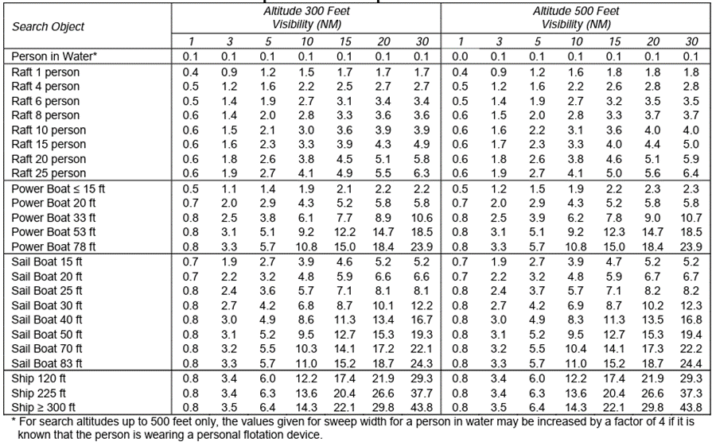

Table Swath width for different flying altitudes and visibility conditions

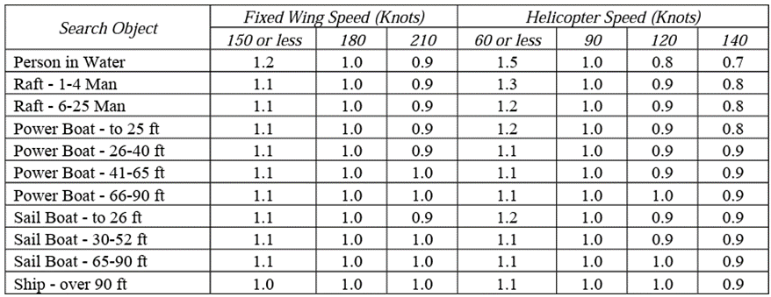

Table Search aircraft speed correction.

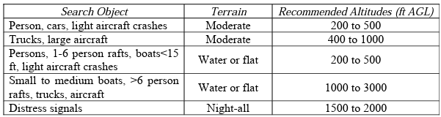

Table Recommended search altitudes

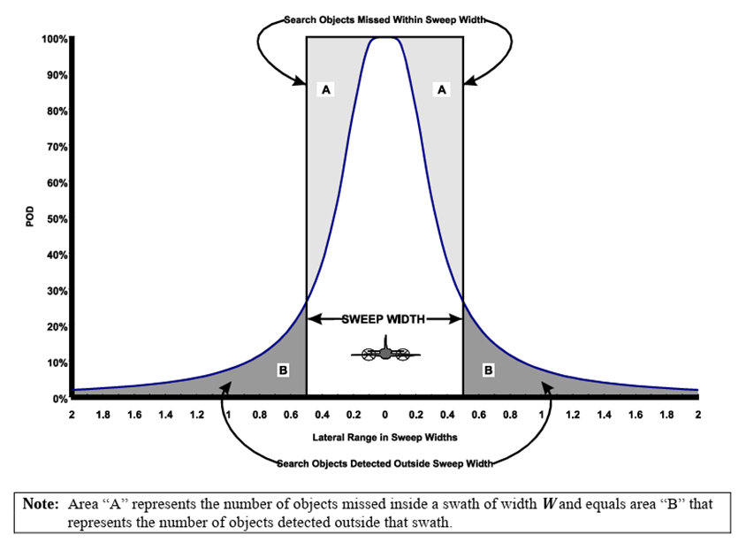

Figure Swath width

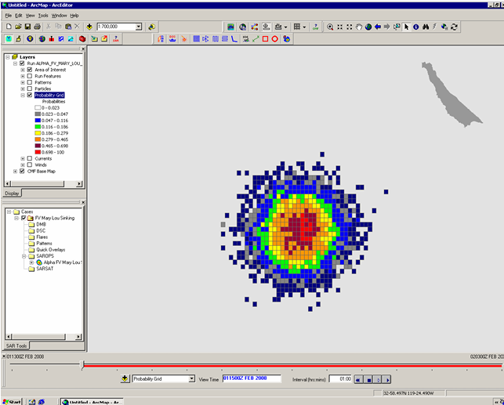

Figure SAROPS probability grid

## Simulation Model

Using the data collected, and manipulating the values for the swath, speed, endurance, device implementation, and area to be searched within Vensim, the simulation software used for this study provides a method by which to test our objective. Using hypothesis-based models defined by integrals, a radius of area to be covered during SAR operations was set from a minima of 0 km² to a maxima of 1200 km². As a baseline, it was determined only the MH-65 design along with its capabilities would be used as part of the current state. The graphs produced for functions shown in Figure 4 and Figure 5 within the Vensim model are dependent on “Armada Drone Implementation” and “MH-65 Dolphin Implementation” as shown in Figure 3. Implementation of either device will control the effect the capabilities have on the graphs outputted by Vensim.

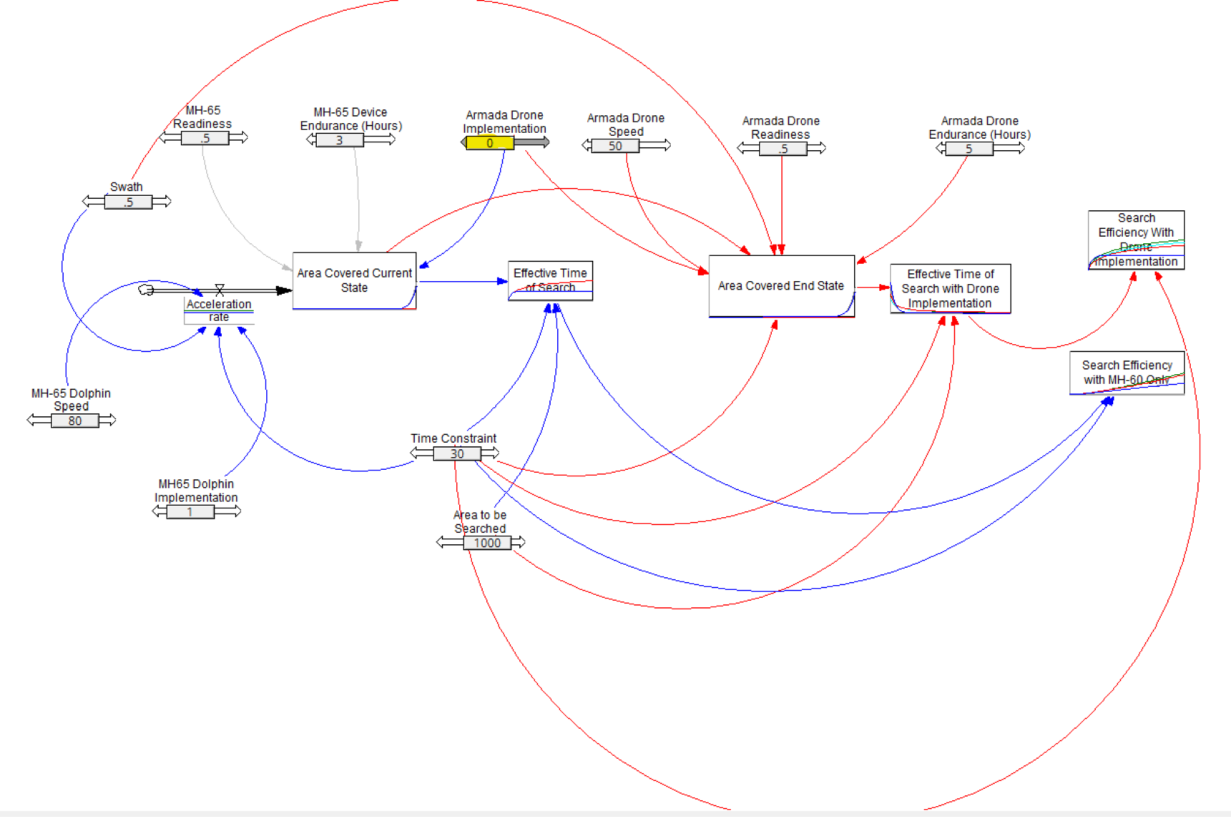

Figure Vensim simulation model

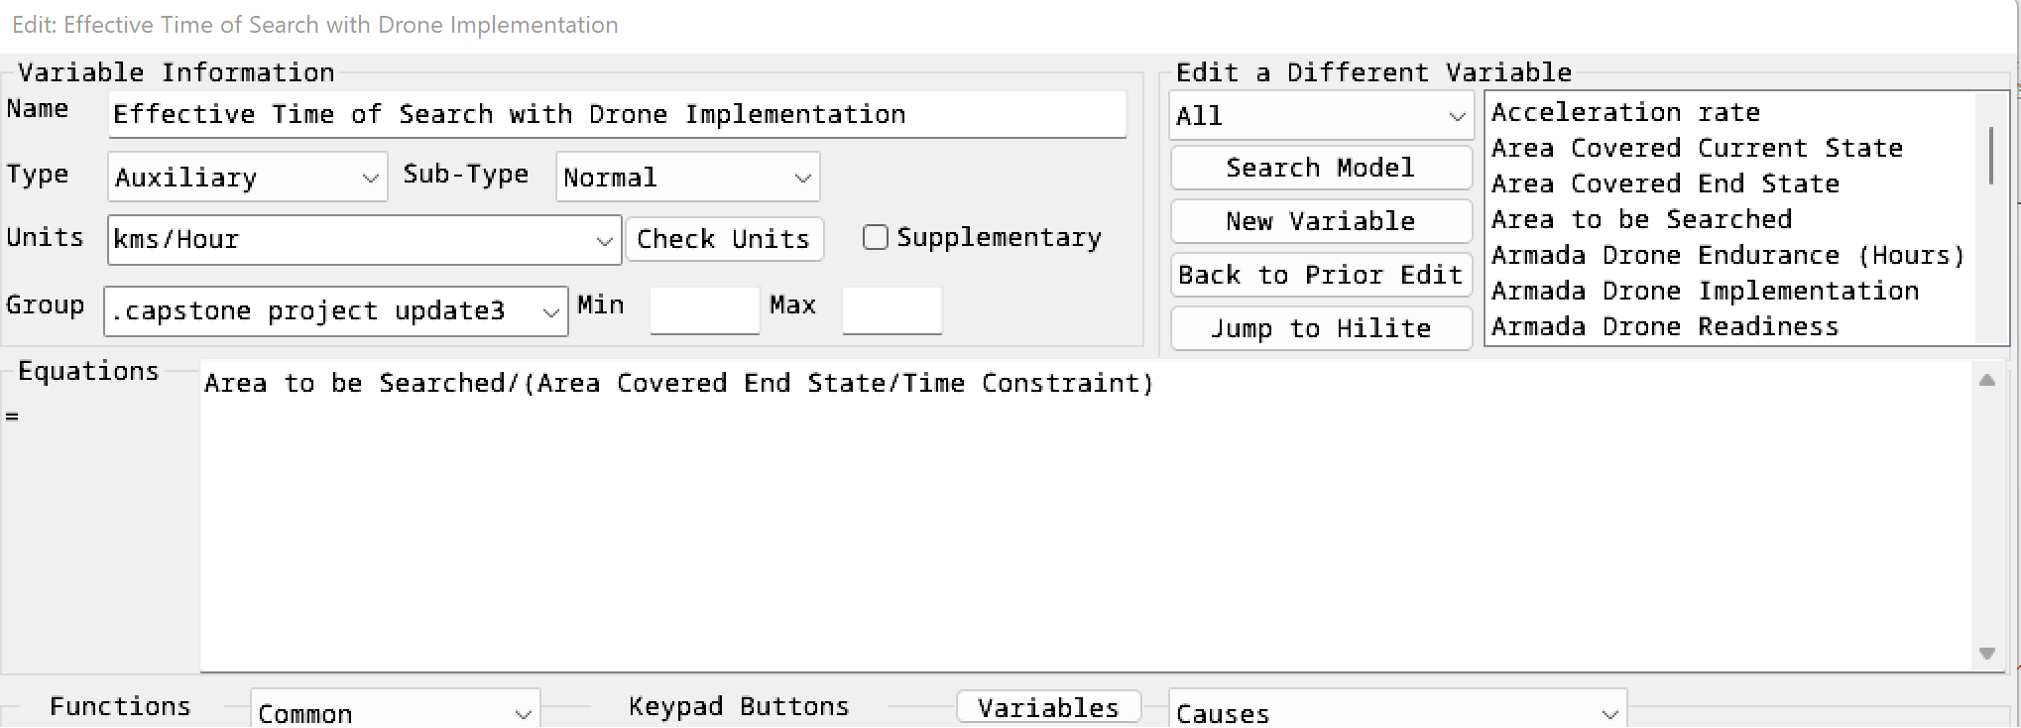

Figure Effective time of search with drone implementation function

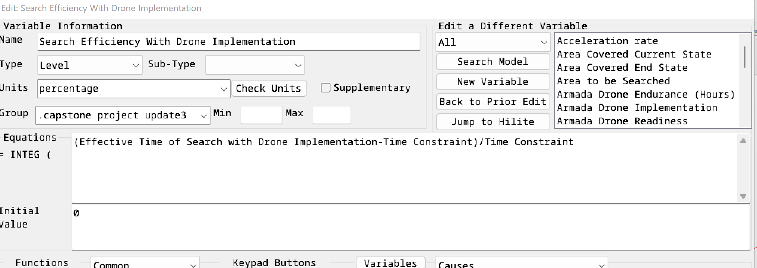

Figure Search efficiency with drone implementation function.

Creating a readable interpretation involved inputting the functions developed in our mathematical model, as detailed in the previous section, to output the graphs as shown for Search Efficiency and Effective Time of Search function editors in Figures 4 and 5. Ultimately, developing a model that allows for the theoretical testing of an objective falls under preliminary design review and further supports a feasibility analysis.

# 

# CHAPTER 3: Interpretation of Results

In the search of optimizing the effectiveness of SAR mission operations, this study ran three different scenarios using mathematical models. Scenario A is a sample scenario that demonstrates the parameters and assumptions used in optimizing the effectiveness of SAR mission operations. Values highlighted in blue represent the variables for MH-65 Dolphin, values highlighted in light yellow represent the variables for Armada Drone, and values highlighted in green represent the variables for aircrafts working in pairs. This will serve as a template for other scenarios, see Figure 6.

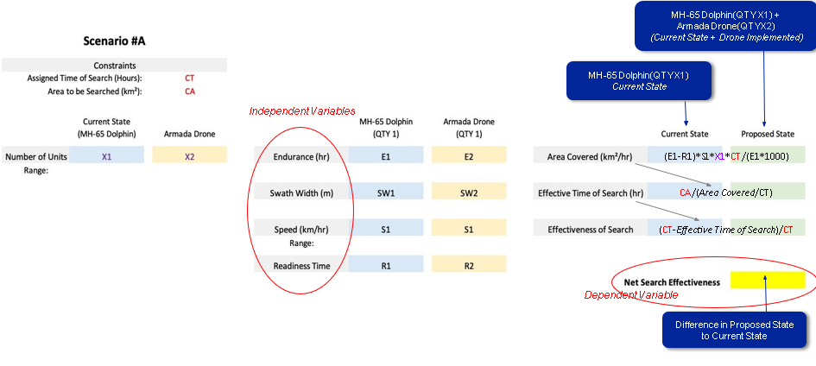

Figure Sample Scenario A

## Constraints & Variables

* Constraints set for the SAR operations are Time of search and Area of search.
* Independent variables are the endurance time, the swath width, the search speed, and the readiness time of both the MH-65 Dolphin and the Armada Drone.
* The dependent variable is the Effectiveness of the search.

## Defined Variables for Scenario #1 & #2

At any given SAR mission, the USCG deploys 3 MH-65 Dolphin along with all associated equipment. Under normal conditions of search, the SAR team is required to cover 1200 km² (Area Constraint) in 24 hours of operation (Time Constraint). The MH-65 Dolphin and Armada Drone have the same swath width of 500 m. The readiness time of the MH-65 Dolphin and Armada Drone is 0.5 hours. This time includes the preparation of the crew, the setup, and the refueling of the aircraft. The search speed for both aircraft is 110 km/h. This information will serve as the basis for evaluating SAR scenarios #1 and #2.

## Scenario #1

In this scenario, we compare the effectiveness of the SAR mission at the current stage to the SAR mission when adding one Armada Drone to the current stage. At the current state, the SAR team uses 3 MH-65 Dolphin with an endurance of 3 hours.

Under the time constraint of 24 hours and the area constraint of 1200 km², the variables are calculated as follows:

* Using equation 1, **Area covered in the assigned time** = (Endurance-Time to setup the aircraft)*(Velocity at searching mode)*(Swath width covered by sensors on board or human sight)*(number of units on the mission)*(time of search)/(Endurance*1000) = (3- 0.5*(110)*(500)*(3)*(24)/(3*1000) = 3300 km².
* Using equation 2, **Effective time of search** = (Area to be covered*Assigned time of search)/(area covered in the assigned time + area covered by drones) = (1200*24)/(3300) = 8.73 hr.
* Using equation 3, **Effectiveness of the search mission** = 1+ (Assigned time of search - Effective time of search)/Assigned time of search = 1+(24-8.73)/24 = 164%.

By introducing one Armada Drone into the search, we obtain the following results:

* Using equation 1, **Area covered in the assigned time** = (11-0.5)*(110)*(500)*(1)*(24)/(11*1000) + 3300 = 4560 km²
* Using equation 2, **Effective time of search** = (1200*24)/(4560) = 6.32 hr.
* Using equation 3, **Effectiveness of the search mission** = 1+ (24 - 6.32)/24 = 174%

When introducing the Armada Drone into the search, we observed an increase in the search area from 3300 km² to 4560 km², a decrease in time of search from 8.73 hours to 6.32 hours, and an increase in the Effectiveness of the search mission from 164% to 174%.

Therefore, the **Net Search Effectiveness** = (**Effectiveness of the search mission when Armada Drone is implemented) - (Effectiveness of the search mission at the current stage)** = 174% - 164% = 10%

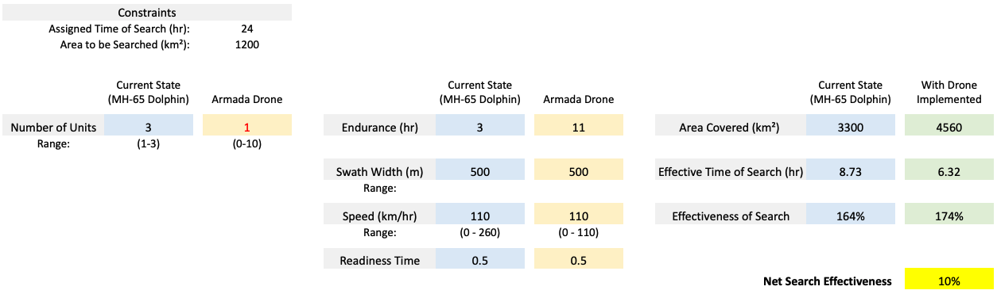

Figure Scenario #1

## Scenario #2

In Scenario #2, we keep all other variables the same as in Scenario #1 but increase the number of drones implemented from a single Armada drone to a pair. By doing so, we obtain the following variables:

* Using equation 1, **Area covered in the assigned time** = (11-0.5)*(110)*(500)*(2)*(24)/(11*1000) + 3300 = 5820 km²
* Using equation 2, **Effective time of search** = (1200*24)/(5820) = 4.95 hr.
* Using equation 3, **Effectiveness of the search mission** = 1+ (24 - 4.95)/24 = 179%

By introducing two Armada Drones into the search, we observe an increase in the search area from 3300 km² to 5820 km², a decrease in time of search from 8.73 hours to 4.95 hours, and an increase in the Effectiveness of the search mission from 164% to 179%.

Therefore, the **Net Search Effectiveness** = 179% - 164% = 16%

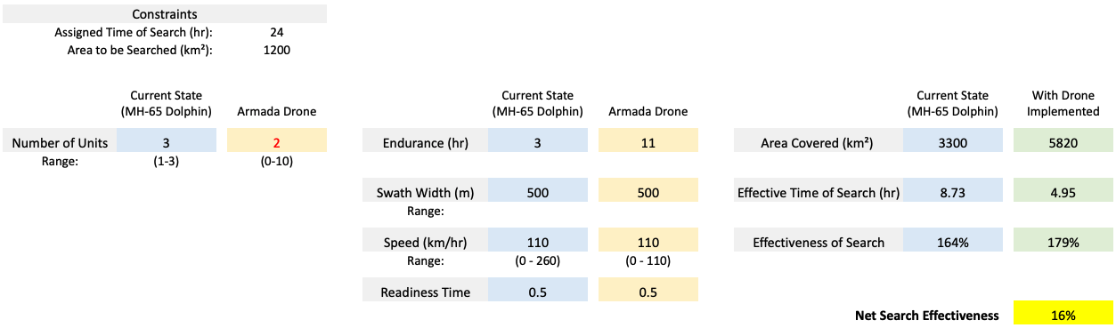

Figure Scenario #2

## Scenario #3

In this scenario, we changed the current state of the SAR mission from deploying three MH-65 Dolphin aircraft to using only one MH-65 Dolphin, especially for scenarios involving larger targets like missing boats or airplanes. In this case, the time constraint is increased to 30 hours and the area constraint is decreased to 1000 km². When we explore the scenario of using only one MH-65 Dolphin for SAR missions while keeping all other conditions the same as in Scenario #1, the new current state variables are calculated as below.

* Using equation 1, **Area covered in the assigned time** = (3-0.5*(110)*(500)*(1)*(30)/(3*1000) = 1375km².
* Using equation 2, **Effective time of search** = (1000*30)/(1375) = 21.82 hr.
* Using equation 3, **Effectiveness of the search mission** = 1+(30-21.82)/30 = 127%.

By introducing one Armada Drone into the search, we obtain the following results:

* Using equation 1, **Area covered on the assigned time** = (11-0.5)*(110)*(500)*(1)*(30)/(11*1000) + 1375 = 2950 km²
* Using equation 2, **Effective time of search** = (1000*30)/(2950) = 10.17 hr.
* Using equation 3, **Effectiveness of the search mission** = 1+ (30 - 10.17)/30 = 166%

When implementing one Armada Drone into the search using the new current state, we observe an increase in the search area from 1375 km² to 2950 km², a decrease in the time of search from 21.82 hours to 10.17 hours, and an increase in the Effectiveness of the search mission from 127% to 166%.

Therefore, the **Net Search Effectiveness** = 166% - 127% = 39%

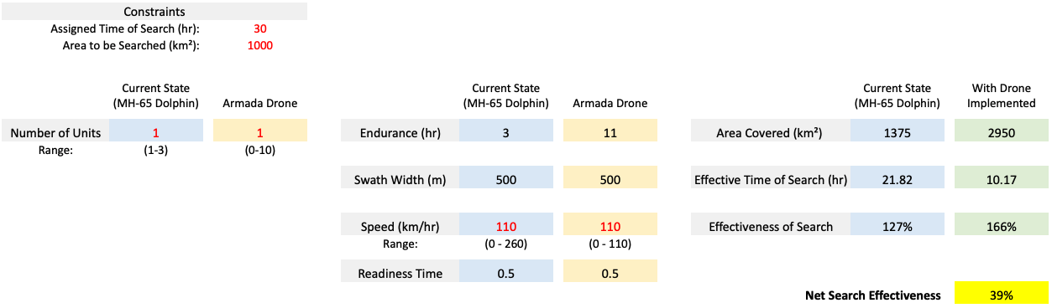

Figure Scenario #3

Figure 10 below shows the output graph for Search Efficiency when inputting all 3 scenarios into our simulation model.

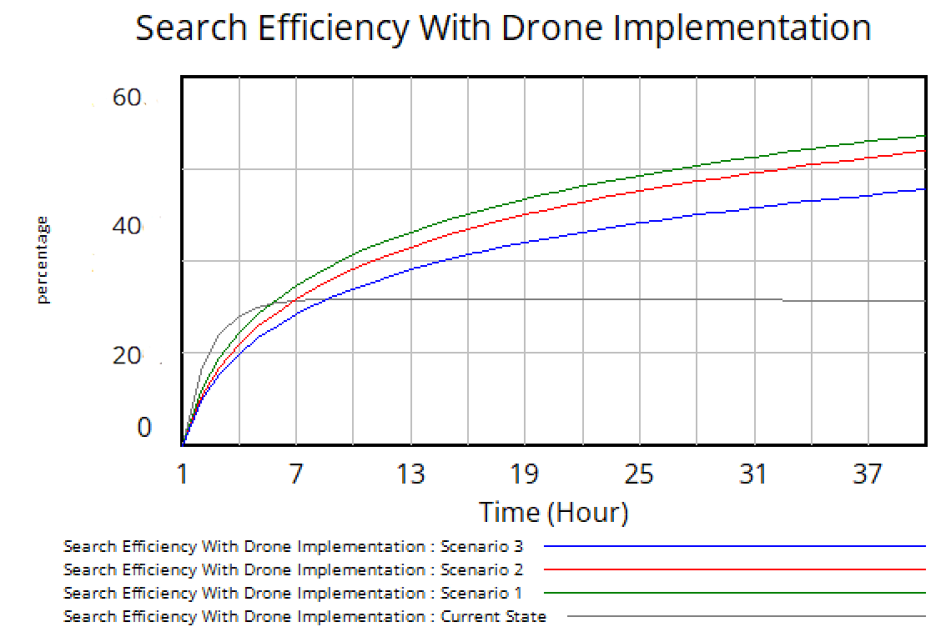

Figure Simulation model results

# CHAPTER 4: Risk Management

Risk management is essential for showcasing the enhanced efficiency of SAR operations through drone integration. Several critical risk areas need careful consideration and mitigation strategies. We utilized a risk cube matrix to clearly identify each risk, and the associated technical, schedule, and cost risks with formulated mitigation steps by utilizing “IF, BY, DUE TO, THEN” statements.

## Capstone Project Risks

**Lack of Information Risk:** States that IF we are unable to find the necessary data for the data collection phase BY the midpoint of Capstone B DUE TO a lack of available information, THEN we will not have the data needed to do our analysis.

The technical impact of this risk would be that we would not be able to complete the analysis on our objective as we proposed in our Letter of Engagement. The schedule impact is a delay in schedule and an impact on the probability of the entire Capstone completion. And there are no cost impacts. The mitigation strategy we chose was contingency planning, identifying and being ready to adjust our objective that is quantifiable and achievable. We did end up deploying this strategy and revised our objective midway through Capstone B.

**Communication Risk:** States that IF we encounter major differences with our sponsor BY any major review checkpoint DUE TO a lack of communication or understanding of the topics, THEN there will be a breakdown of collaboration between the team and the sponsor.

The technical impact is that our final paper deliverable will not be in line with what the sponsor wanted. The schedule impact is the same as the Lack of Information Risk and there are no cost impacts. The mitigation strategy we assigned was to maintain stakeholder involvement, keeping constant communication with the sponsor so we could pivot quickly if needed.

## Armada Drone Implementation Risks

**Supply Chain Disruptions Risk:** States that IF Armada isn’t able to produce enough drones for the USCG Search and Rescue Operations within the agreed-upon timeline, DUE TO limited resources or supply chain disruptions, THEN it may result in operational delays for the USCG.

The technical impact is that this delay could hinder the USCG's ability to respond promptly to emergency situations and carry out effective search and rescue missions. The schedule impact is the delay in the production schedule and final delivery to the USCG. The cost impact is a loss of profit margin for Armada (due to missed milestones and slips in the delivery schedule). The mitigation strategy we assigned is contingency planning. Armada should assess its production capacity and, if necessary, invest in expanding manufacturing capabilities to meet the demand. This may involve increasing production lines, hiring additional skilled personnel, or outsourcing certain components if it accelerates production.

**Limited Range of Communication Risk:** IF the Armada drone is limited in search range DUE TO the limited range of its current cellular communication system, THEN this will result in a max range search of 180 km.

The technical impact is a limit to the search range for SAR operations. The mitigation strategy we recommend is to implement a redundant communication system that can expand the drone’s current communication range of 180 km by using satellite, Starlink, or RF signals.

**Cyber Security Risk:** IF the Armada drone does not have an implemented cyber security protocol within the drone system DUE TO an oversight in encryption or secure communication protocols in the design application THEN the system may be vulnerable to cyber-attacks and risk being overtaken by adversaries.

The technical impact would be a complete loss of the SAR operation due to a failure in the drone system. The mitigation strategy we recommend is to protect the drones by using countermeasures in the design and inputting cybersecurity protocols, ensuring software is updated regularly, and using secure communication channels.

**Maritime Environment Drone Exposure Risk:** IF the harsh coastal environmental conditions are not considered in the operation of the drone DUE TO the drones not being originally designed for maritime environments, THEN the drone can experience damage to its structure, electronics, and propulsion system due to corrosion.

This would accelerate corrosion on the drone, shortening its lifetime use period. The mitigation strategy we recommend is to use protective coatings and corrosion-resistant materials against salt, air, and water, including regular maintenance of the drone.

# CHAPTER 5: Conclusions and Recommendations

In conclusion, the team answered the important question: Can the implementation of a gasoline-powered long-range drone enhance the efficacy of SAR missions conducted by the USCG? We followed a systematic approach, encompassing problem definition, establishing key objectives, project decomposition, morphology, and the development of an analytical simulation model. Throughout this process, we maintained a strong ethical framework, recognizing the potential to save lives through increased search effectiveness.

By benchmarking the current search effectiveness at 100%, we set out to determine if the implementation of the Armada drone could yield a 10% improvement in search effectiveness. Our approach, rooted in specific, measurable, achievable, realistic, and time-bound (SMART) objectives, aimed to reduce the average time required to locate and initiate rescue for distressed individuals, ultimately contributing to the US Coast Guard's mission of saving lives.

Interpretation of results showcased three different scenarios, each demonstrating the potential benefits of implementing Armada's drone in SAR missions. The results indicated that the drone could significantly increase search area coverage, reduce search time, and improve overall mission effectiveness by 10% to 39%.

The scope of our project was thoughtfully defined, focusing on key variables such as endurance, swath width, speed, and readiness time, and was represented through a simulation model. It is essential to acknowledge the limitations of our study, which excluded various factors like location, weather conditions, equipment, training, and the specific nature of the mission. These exclusions were deliberate, as our study concentrated on specific elements relevant to the primary research question.

In summary, this study represents a valuable contribution to the exploration and applicability of gas-powered long-range drones by examining the potential benefits of integrating advanced drone technology into critical search and rescue missions. The results and insights obtained from our analysis and simulation model offer a promising perspective for enhancing the effectiveness of USCG operations, potentially leading to more lives saved in emergency situations. As we conclude this study, we anticipate that the knowledge gained here will inspire further exploration and innovation in the field of search and rescue technology and its applications within the United States Coast Guard.

## Lessons Learned

**Having Clear and Defined Objectives:** At the start of the project, the team had a broad objective of having lives saved and made a shift to a more specific objective of expanding the search effectiveness by 10% for a more focused approach. By doing so the team was able to articulate the expected outcomes and help align the team's efforts towards achieving those outcomes.

**Adaptability:** The project team had to adjust its objectives and approach when faced with data limitations and sponsor expectations. By collecting and analyzing relevant data, the project team was able to reject the initial objective and adjust project strategies accordingly. Requiring flexibility in the project management style.

**Risk Management:** Identifying the potential risks and developing mitigation strategies are considered crucial during the implementation.

**Complexity in Interoperability:** The complexity of incorporating long-range gas-powered into an established operation such as SAR mission operations demands flexibility and effective risk management.

## Recommendations

**Cybersecurity Safeguards:** Implementing cybersecurity protocols to protect sensitive information and the drone system from potential threats.

**Consideration of Environmental Impacts on ICE-Drones:** Assess and implement corrosion resistance measures that coastal environments can impact the ICE-3333333333333333333333333333drones.

**Enhancing Communication:** Recognizing communication limitations, and integrating a communication system that can expand the drone’s current communication range of 180 km.

# 

# Appendices

## Appendix A: Capstone Milestone & PERT Tables

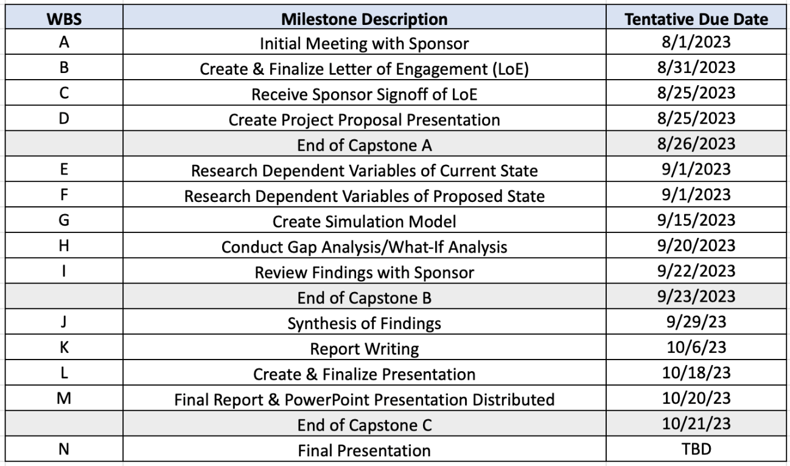

Table A Project milestones

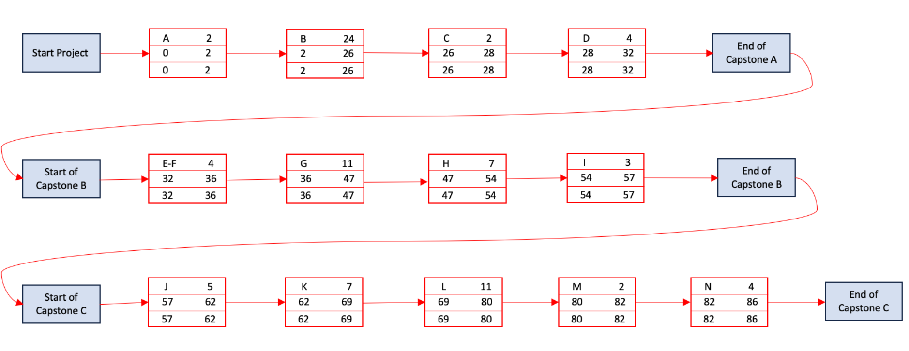

Figure A PERT diagram

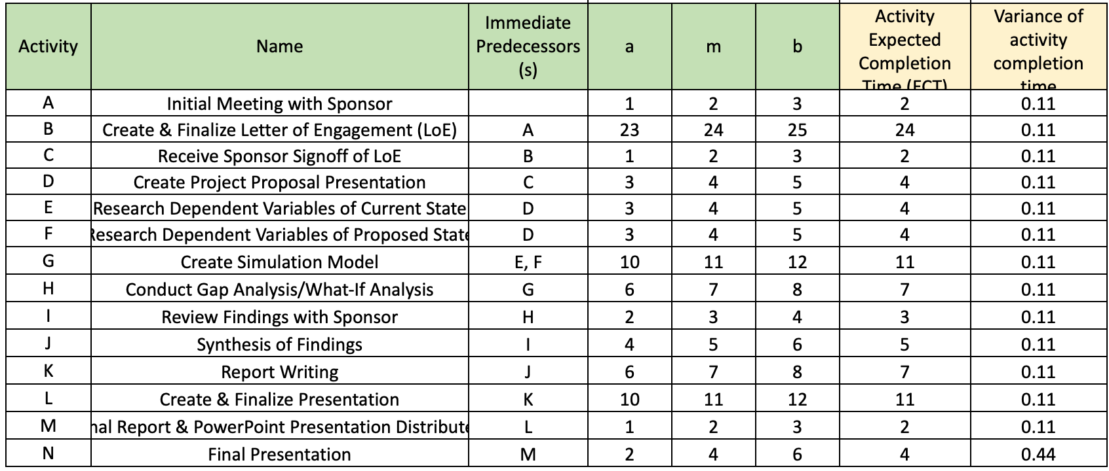

Table A PERT estimated time of completion

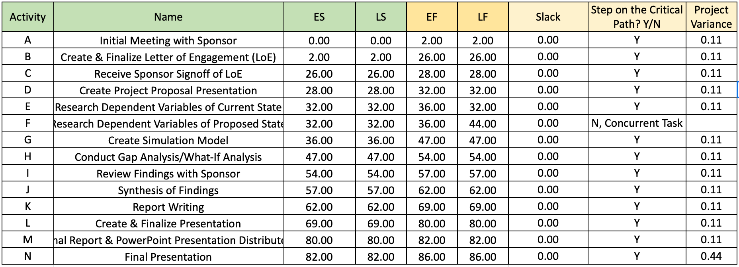

Table A Critical path & standard deviation

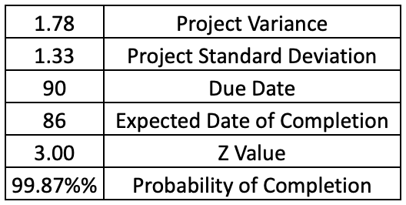

Table A PERT probability of project completion

## Appendix B: Letter of Engagement

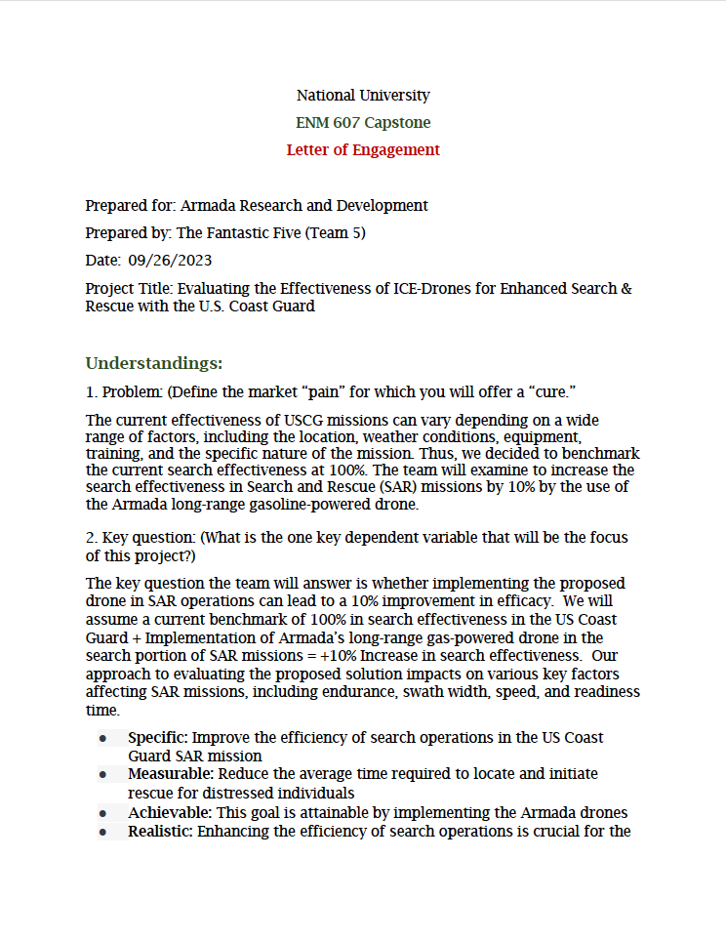

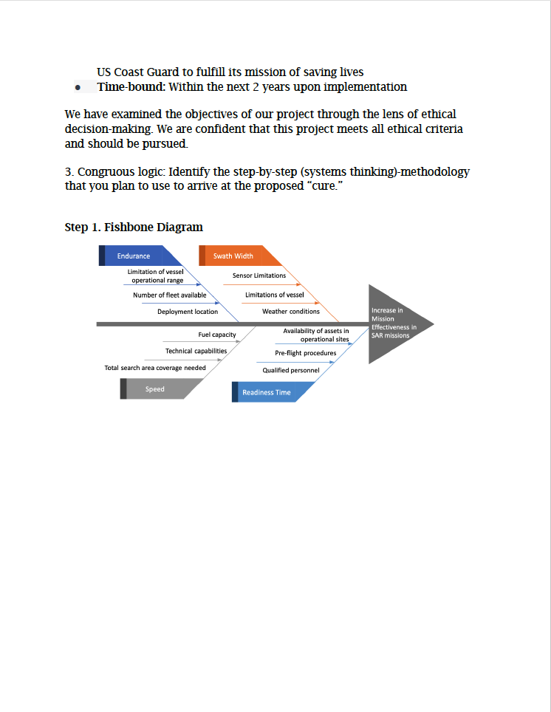

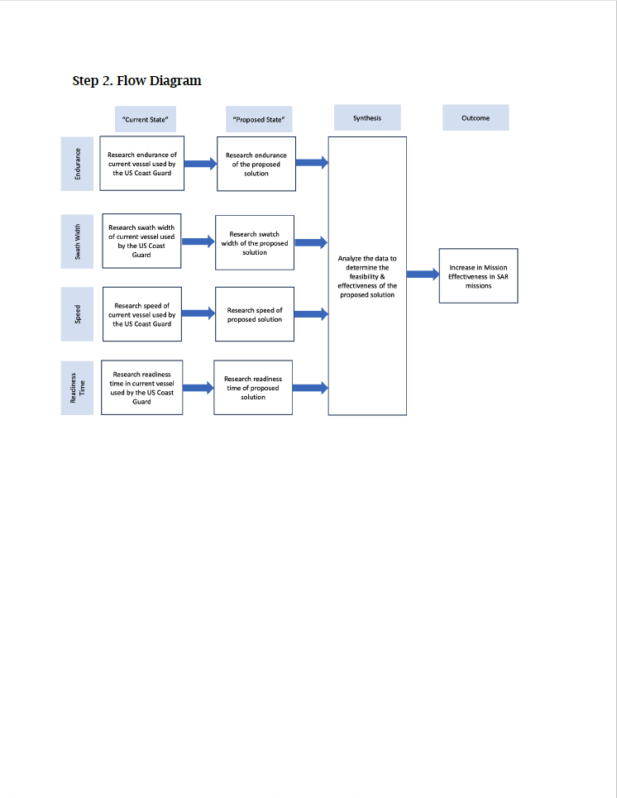

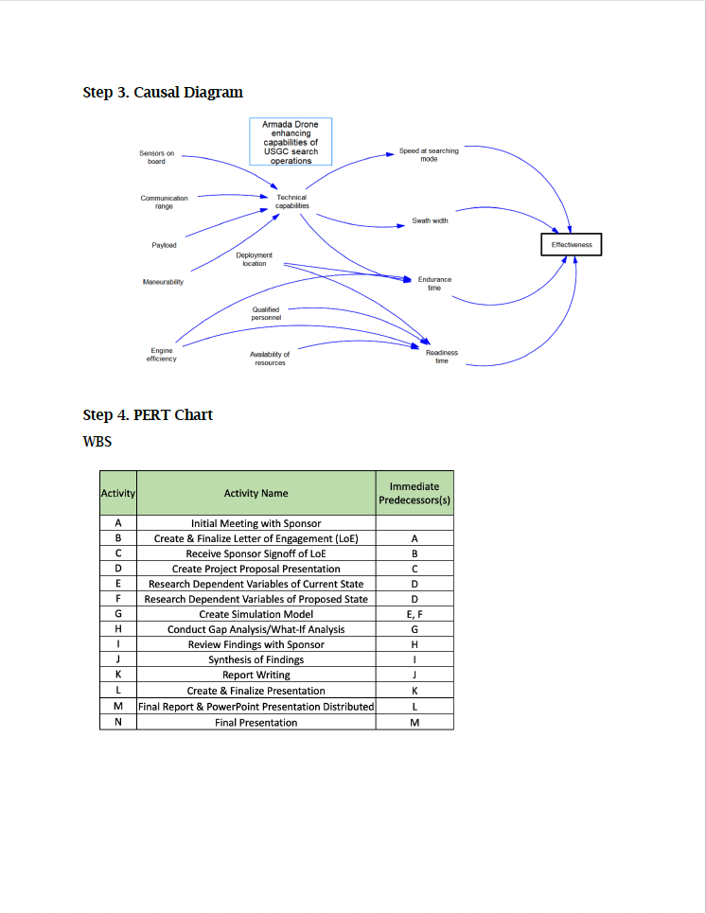

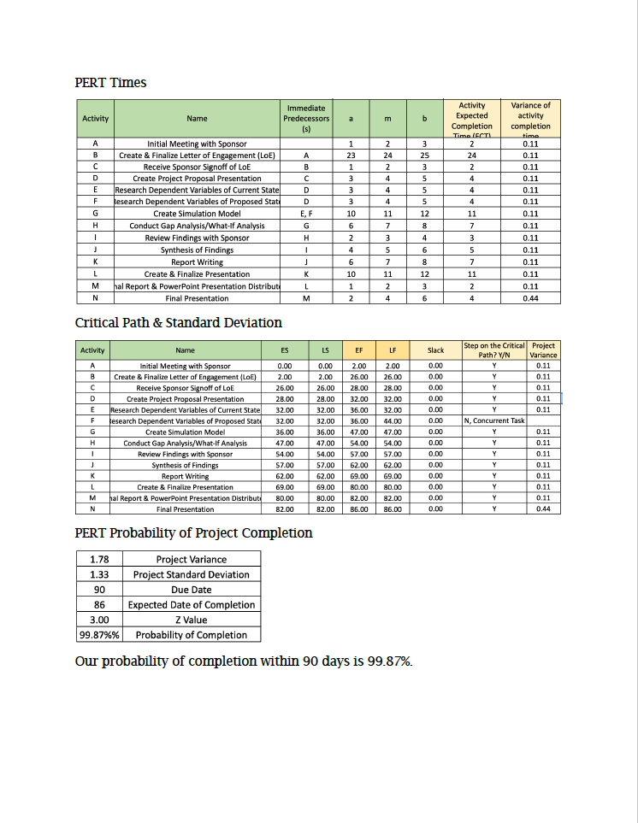

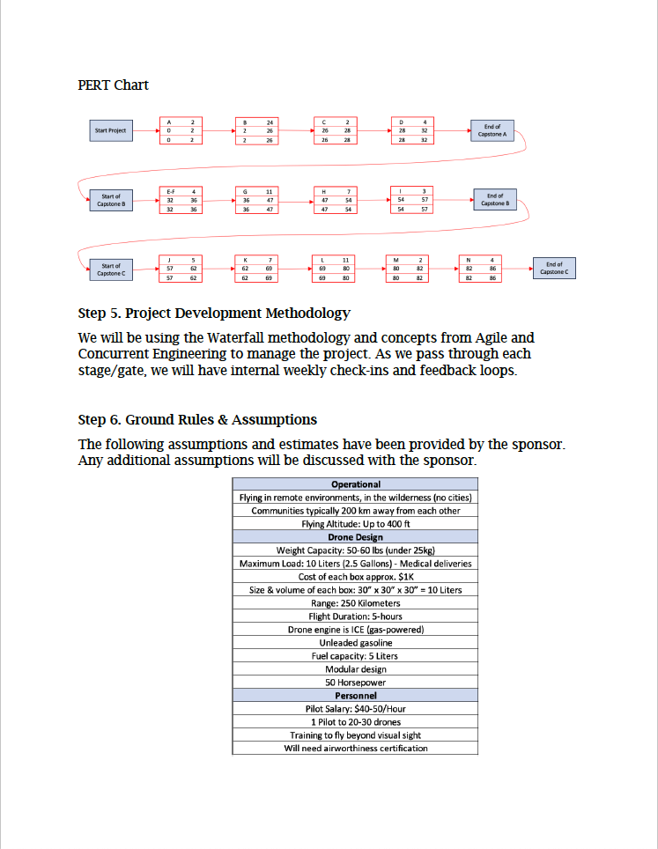

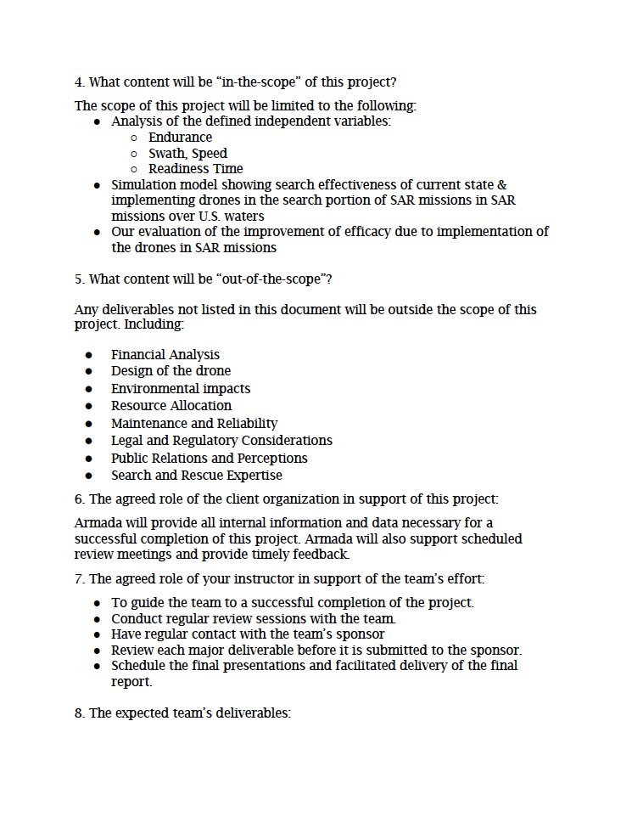

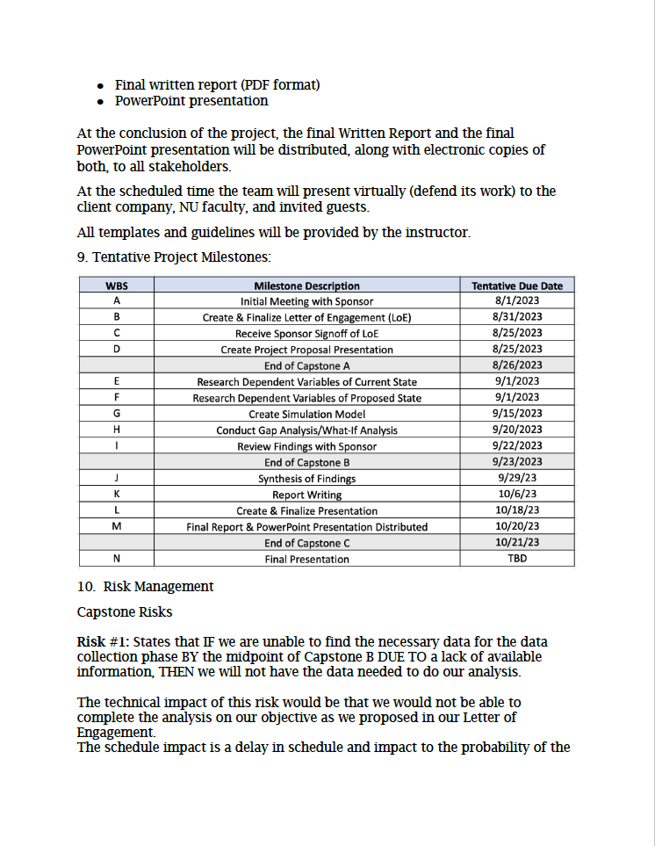

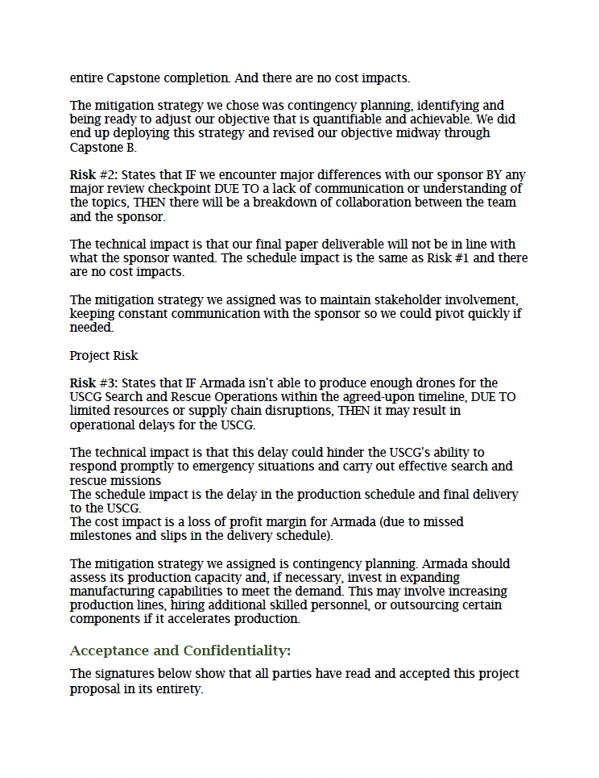

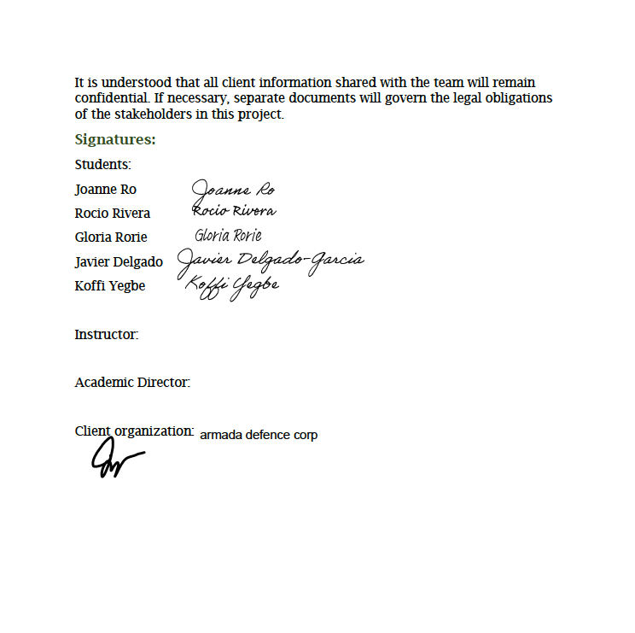

Professor Podobas has released this Letter of Engagement on October 12, 2023.

## Appendix C: Project Decomposition and Morphology Chart

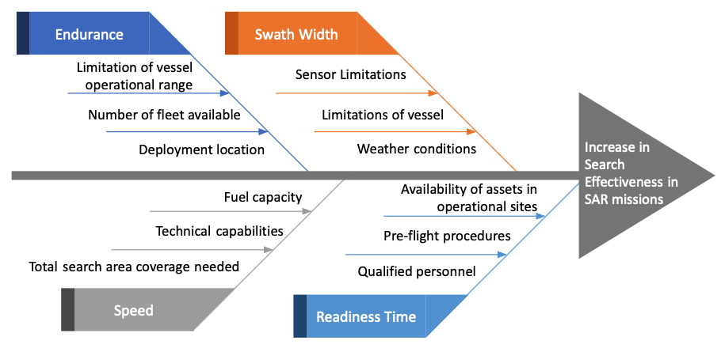

Figure C Fishbone diagram

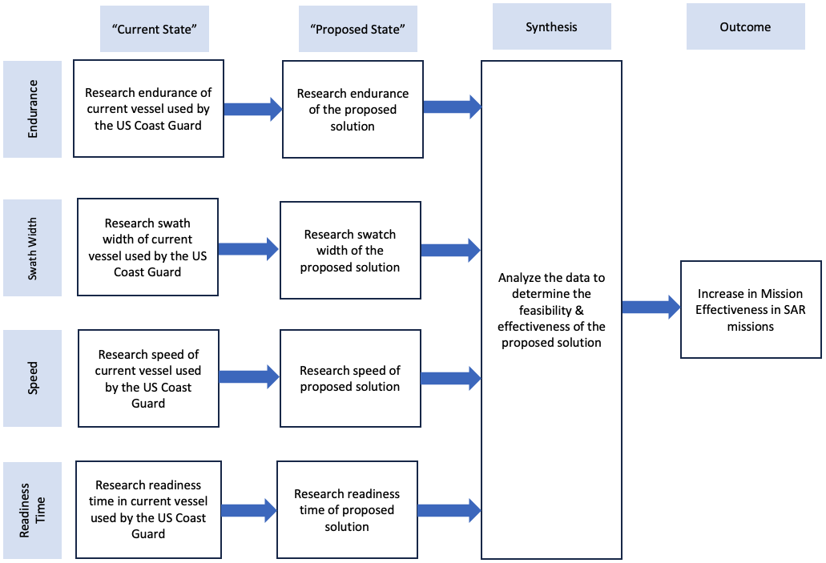

Figure C Flow diagram

# References

Murray, K. (2021, November 15). *Coast Guard drones can see underwater and inside vessels during response to hurricanes and extreme weather events*. United States Coast Guard. Retrieved September 30, 2023, from https://www.mycg.uscg.mil/News/Article/2841972/coast-guard-drones-can-see-underwater-and-inside-vessels-during-response-to-hur/

Office of Program Analysis and Evaluation (CG-PAE). (2023, January 26). *U.S. Coast Guard: FY2022 performance report*. ArcGIS StoryMaps. Retrieved September 29, 2023, from https://storymaps.arcgis.com/stories/2834ff7be6874a94accf430b1c11a178

United States Coast Guard (USCG), U.S. Coast Guard Addendum to the National Search and Rescue Supplement (NSS) to the International Aeronautical and Maritime Search and Rescue Manual (IAMSAR), Appendix H. Accessed 7 Sep 2023.

United States Coast Guard, n.d. MH-65 Short Range Recovery Helicopter. Retrieved 18 Sep 2023 from https://www.dcms.uscg.mil/Our-Organization/Assistant-Commandant-for-Acquisitions-CG-9/Programs/Air-Programs/SRR-MH-65/