**Oil Giants, With Billions in Profits, Face Criticism and an Uncertain Outlook**

Exxon Mobil and Chevron reported another round of strong profits. But they face political fire over gasoline prices, even as they fear a new downturn.

Top of Form

Bottom of Form

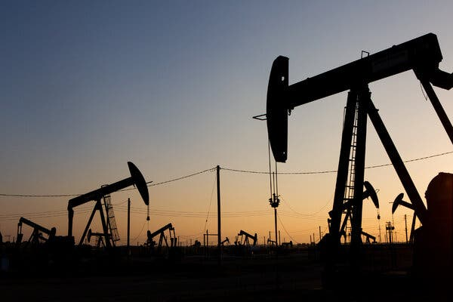

The high commodity prices and record profits through much of the year have increased political pressure on oil companies to increase production.Credit...Alex Welsh for The New York Times

**By**[**Clifford Krauss**](https://www.nytimes.com/by/clifford-krauss)

Reporting from Houston

* Oct. 28, 2022

The good times are back for the oil companies, but with the global economy on edge, there is more caution than celebration among executives.

On Friday, Exxon Mobil and Chevron, the largest U.S. oil companies, reported a fourth consecutive quarter of robust profits. In part, the bonanza reflected a surge in oil and natural gas prices after the Russian invasion of Ukraine scrambled global energy markets.

As the bottom lines have grown fatter, however, the companies are on the defensive.

President Biden has pushed them to reinvest their profits in production and refining to help reduce gasoline prices at a time of rapid inflation. “You should not be using your profits to buy back stock or for dividends,” he said recently at the White House.

That is exactly what oil executives have been doing, rewarding investors after a decade of poor returns. The companies and their Wall Street investors have been giving priority to dividend increases and stock buybacks rather than following their past practice of pushing production when prices are high only to force prices down and reduce profits.